**ASSESSMENT AND INTERNAL VERIFICATION FRONT SHEET (Individual Criteria)**

|  |  |  |  |  |  |  |
| --- | --- | --- | --- | --- | --- | --- |
| Course Title | Advanced Diploma in IT (MQF Level 4) | | | Lecturer Name & Surname | Jonathon Brincat | |
| Unit Number & Title | | **ITSFT-406-1506–Client-Side Scripting** | | | | |
| Assignment Number, Title / Type | | **02, Client-Side Scripting Project (Home Assignment)** | | | | |
| Date Set | | **05-12-2022** | **Deadline Date** | **11-01-2023** | | |
| Student Name | Sven Mallia | | **ID Number** | **260805L** | **Class / Group** | **4.2B** |

|  |  |  |
| --- | --- | --- |
| Assessment Criteria | Maximum Mark | Mark Achieved |
| *KU1.3: Describe the methodology used in a supporting technology* | 5 |  |
| *KU1.4: Identify advantages of supporting technologies* | 5 |  |
| *KU1.5: Describe the necessity for responsive design* | 5 |  |
| *KU1.6: Explain the need for validation of input on the client* | 5 |  |
| *KU3.3: Examine and ensure form validation is carried out on the client* | 5 |  |
| *KU3.4: Test, log, identify, and rectify errors ensuring testing using a number of browsers* | 5 |  |
| *AA2.3: Use event handlers to enhance the user experience* | 7 |  |
| *AA2.5: Apply scripts to validate user input and to improve a design element* | 7 |  |
| *AA2.6: Apply scripts to improve image presentation* | 7 |  |
| *SE3.1: Create an interactive web application making use of scripting techniques to enhance functionality* | 10 |  |
| *SE3.2: Create a dynamic navigation system* | 10 |  |
| Total Mark | **71** |  |

|  |
| --- |
| **Notes to Students:** |
| * This assignment brief has been approved and released by the Internal Verifier through Classter. * Assessment marks and feedback by the lecturer will be available online via Classter (<Http://mcast.classter.com>) following release by the Internal Verifier * Students submitting their assignment on VLE/Turnitin will be requested to confirm online the following statements:   **Student’s declaration prior to handing-in of assignment**   * I certify that the work submitted for this assignment is my own and that I have read and understood the respective Plagiarism Policy   **Student’s declaration on assessment special arrangements**   * I certify that adequate support was given to me during the assignment through the Institute and/or the Inclusive Education Unit. * I declare that I refused the special support offered by the Institute. |

Advanced Diploma in IT (MQF Level 4)

ITSFT-406-1506: Client-Side Scripting

**Home Assignment: Client-Side Scripting Project**

**Assignment Guidelines**

* This assignment is a **Home Assignment** and should be strictly completed by **11th January 2023**.
* Fill in the assignment **cover sheet completely**. The student’s assignment cover sheet should be attached to the project being submitted. Note that assignments handed in without the cover sheet will be considered as ***Not Submitted***.
* Answer all the questions in a structured document and relevant programs/files.
* Highlight clearly the Criteria Number/Question Number and your answer in your work.
* Submission method: **soft copy only** through **VLE** (more instructions will be given by your lecturer).
* **Plagiarism is strictly prohibited. Proper references must be used**. **Copying** will be **penalized** in line with the College’s disciplinary procedures.
* **Individual interviews** may be held and hence the achievement of marks will depend on the outcome of the interview accordingly.

Q6.

Within using the Carousel gallery, the benefits achieved are that the images are displayed nicely depending on the device and can act as some form of a slide show. Another benefit is that only 1 image is displayed at a time so that the gallery page is not cluttered with 4 different images in one section.

Using the burger button menu for smaller/narrow screen devices also had the benefits of offering a way for the user if they want to view the navigation menu or not while going through the webpage on their smartphone screen device.

Responsive Web design is important and desirable so that the contents of a website can adapt to any device depending on the resolution which can greatly improve user experience.

Q7.

|  |  |  |  |  |  |
| --- | --- | --- | --- | --- | --- |
| **Project:** | **Navigation Bar Menu** | | | | |
| **Author:** | **Sven Mallia** | | | | |
| **Test Case number:** | **1** | | | | |
| **Test Case Title:** | **Burger button** | | | | |
| **Test Case Description:** | **This test is to check whether the burger button works in the browser Firefox** | | | | |
| **Steps**  **Performed** | | **Expected outcome** | **Actual**  **outcome** | **Result (Pass/Fail)** | **Further comments** |
| 1. Open webpage on Firefox 2. Right click on webpage and click Inspect 3. Enter Responsive Design Mode (view on smaller screen) 4. Click on Burger Button and show navbar | | Burger button showing | Burger button showing | Pass |  |

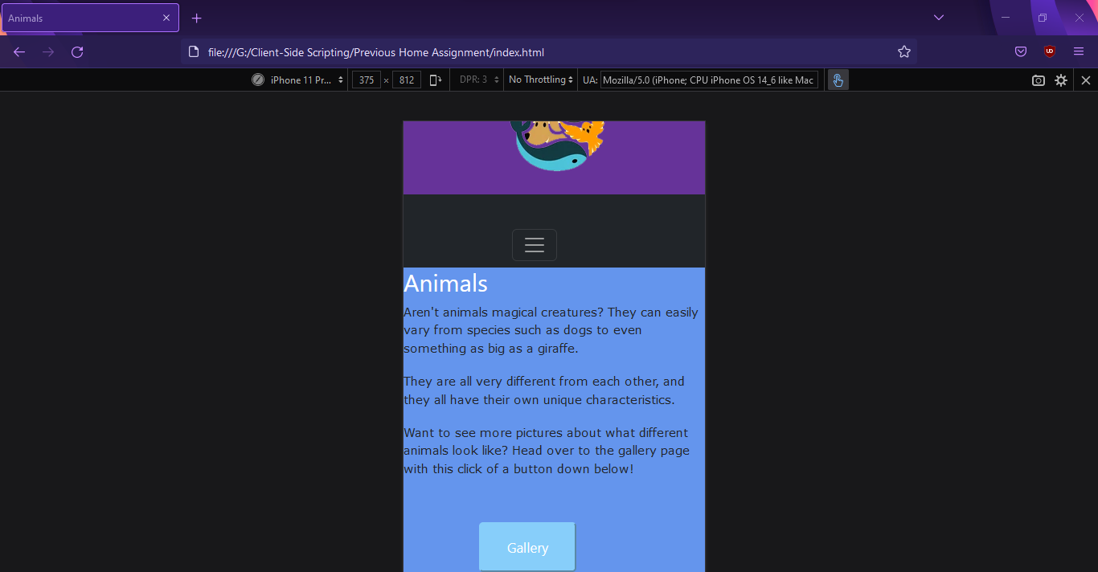

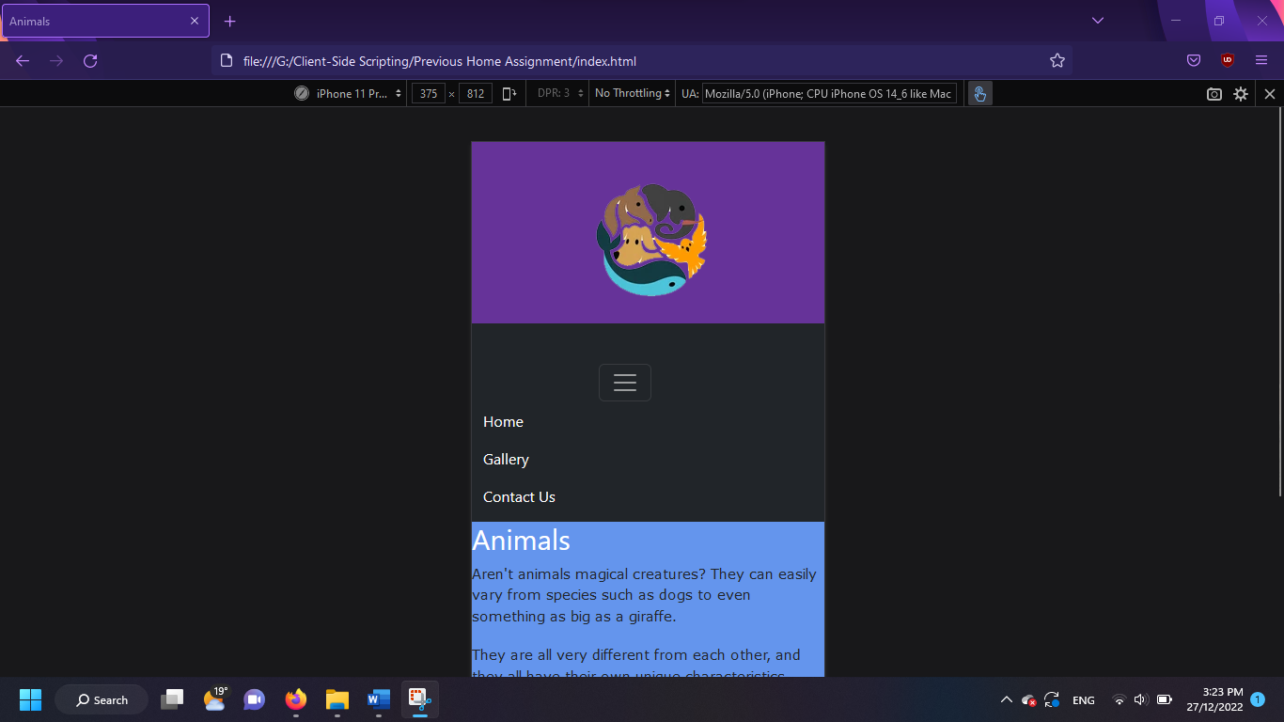

|  |  |  |  |  |  |
| --- | --- | --- | --- | --- | --- |
| **Project:** | **Navigation Bar Menu** | | | | |
| **Author:** | **Sven Mallia** | | | | |
| **Test Case number:** | **2** | | | | |
| **Test Case Title:** | **Burger button** | | | | |
| **Test Case Description:** | **This test is to check whether the burger button works in the browser Google Chrome** | | | | |
| **Steps**  **Performed** | | **Expected outcome** | **Actual**  **outcome** | **Result (Pass/Fail)** | **Further comments** |
| 1. Open webpage on Google Chrome 2. Right click on webpage and click Inspect 3. Enter Responsive Design Mode 4. Click on Burger Button and show navbar | | Burger button showing | Burger button showing | Pass |  |

